# How to make an IoT based weather monitoring system using Nodemcu and Thingspeak

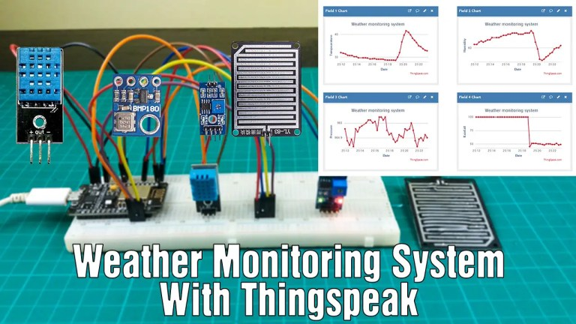

## **What is the Thingspeak?**

Thingspeak is a web application designed for data collection, visualization, and analysis. This is primarily designed for IoT technology. Also, we can monitor the data received through the sensors in real-time. This is an open-source IoT application so we can use it as we want. Also, this application can be used with various development boards like Arduino, Nodemcu, and raspberry pi.

## **The process of this system**

ThingSpeak is an Internet of Things (IoT) analytics platform that allows us to collect, analyze, and visualize data from connected devices or sensors. It is a web-based service provided by MathWorks, the company behind MATLAB, and it is designed to simplify IoT application development and data analysis.

With ThingSpeak, we can create channels to collect data from various IoT devices and sensors. These devices can be anything from weather stations, temperature sensors, humidity sensors, GPS trackers, or any other type of device that can send data over the internet. Each channel has a unique identifier and can store multiple fields of data.

Once the data is collected, ThingSpeak provides various tools for analyzing and visualizing the data in real-time. We can create custom visualizations such as charts, graphs, gauges, and maps to better understand the data patterns and trends. ThingSpeak also offers built-in MATLAB analytics capabilities, allowing us to apply advanced mathematical algorithms and perform data processing tasks.

In addition to data collection and analysis, ThingSpeak provides integration with other services and platforms. We can easily integrate ThingSpeak with popular IoT platforms, like Arduino and Raspberry Pi, or connect it to external services such as Twitter, IFTTT (If This Then That), or MATLAB. This enables us to automate actions or trigger events based on the data received from our devices.

ThingSpeak is commonly used for a wide range of IoT applications, including environmental monitoring, home automation, agriculture, industrial monitoring, and more. Its user-friendly interface, powerful analytics features, and extensive integration options make it a popular choice among developers and hobbyists working with IoT devices and data.We are using it for deployment of our IoT based Weather Station.

When this system is powered on, the Nodemcu board connects to the algorithm development system called MATLAB through the Thingspeak cloud. Then, values are obtained from the sensors. Also, these values are sent to the thingspeak app using the internet. Then, we can see the values as a visualization on the screen.

So, let’s do this project step by step.

### **Step 3**

Thirdly, we set up the Thingspeak app. To do this, follow the steps below.

* First, go to Google Search Engine and search Thing Speakv official website. Open the Thingspeak website and create a new account using your email address. Then, click the “New channel” button.

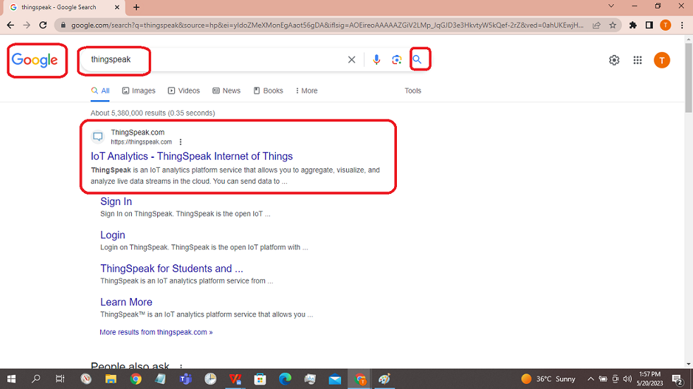

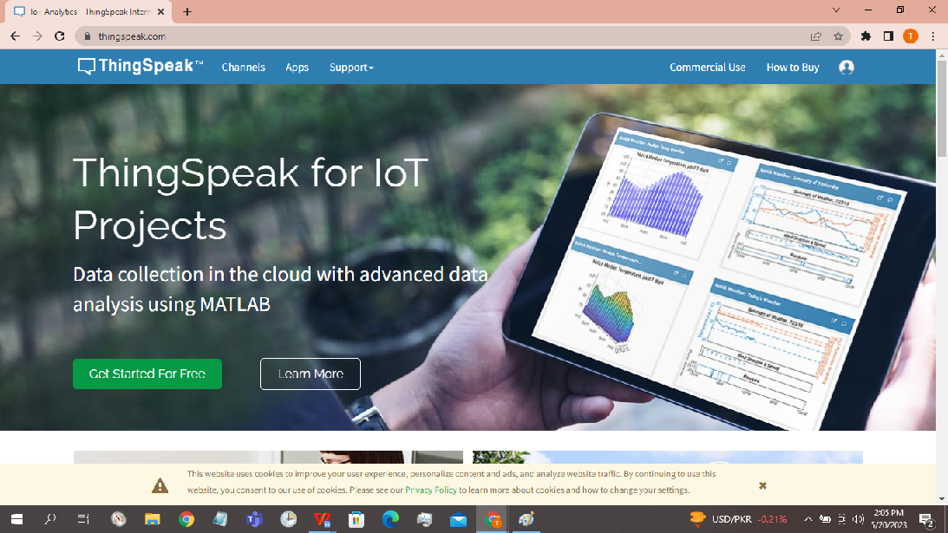

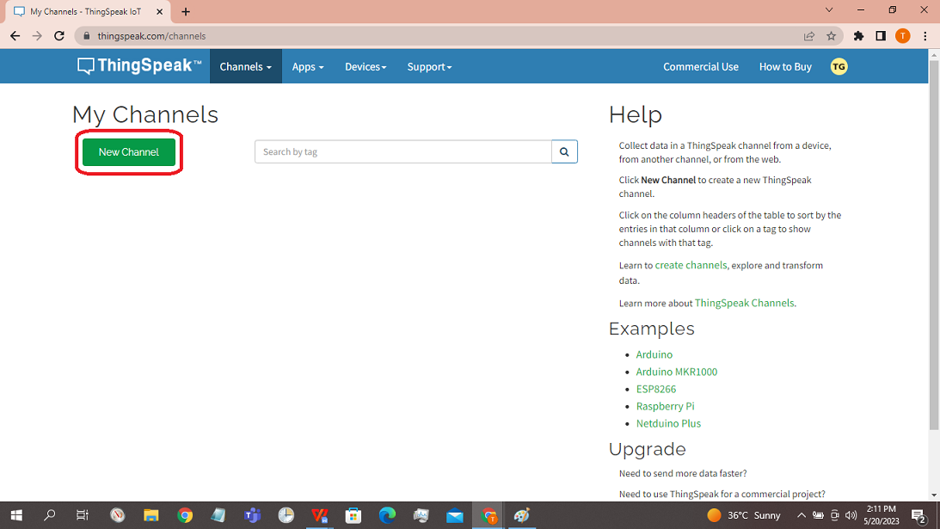

* Next, entered our project name as “Weather Station”and its description. Then, activated the four fields and named them Temperature, Humidity, Pressure, and Rain respectively. After, click the “Save channel” button.

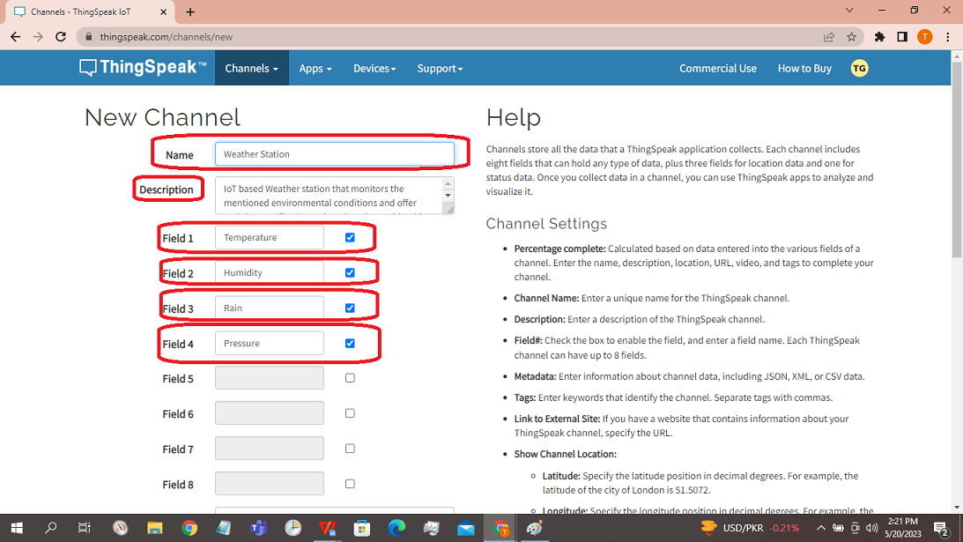

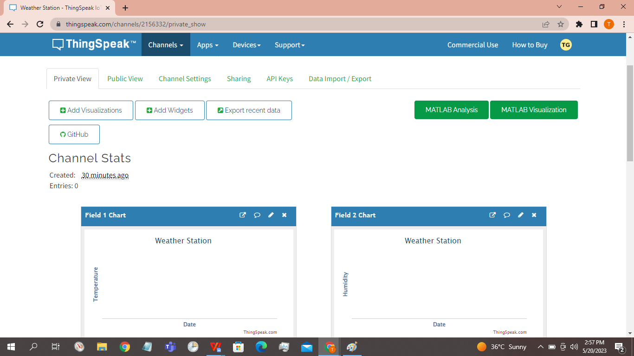

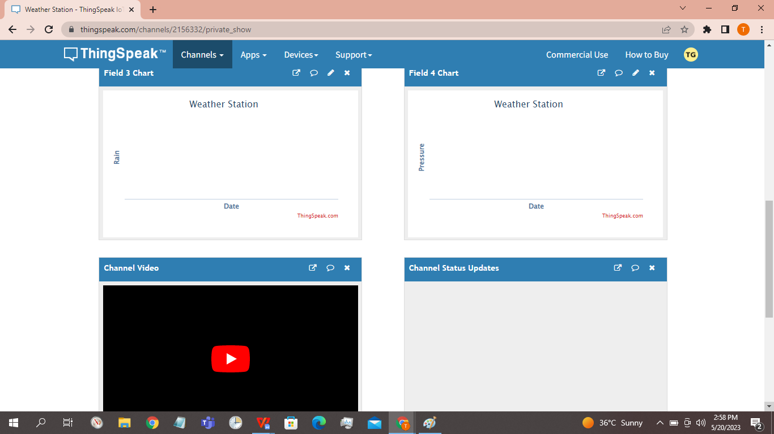

Step 4

Now, let’s create the program for this project. It is as follows.

WI-Fi library — Download

BMP180 library — Download

DHT11 library — Download